Kaikorai Valley College 2015

MINISTRY OF EDUCATION FUNDED MUSIC TUITION
ALL LESSONS ARE IN A SMALL GROUP
- 30 minutes, in school time, and are for the full year.
- Lesson times are rotated if possible to avoid missing the same subject every week. Students are expected to do their best to catch up on class work missed (most manage this well)
CARE OF INSTRUMENTS
Students are expected to follow carefully the tutor’s advice about care of their instrument. Repair for damage to a school instrument due to carelessness or neglect will be charged to the students.
INSTRUMENTS AVAILABLE FOR HIRE
Wind: Flute, Clarinet, Saxophone
Strings: Violin (no spaces for cello this year but do let us know if interested).
COST OF HIRE
$100 for the year.
No charge if you have your own instrument.
JUNIOR COLLEGE - GUITAR
Tuition is also available for Guitar (beginner, and 2nd year students only). There is no cost for this. To make lesson worthwhile though, students need to have a guitar to use at home.
MAKING PROGRESS
It is our experience that the students who make satisfying progress are generally those who have at least one adult that actively encourages and supports their child at home, both in their practice, and in reminders to bring their instrument to school when neessary.
CONTRIBUTING TO SCHOOL MUSIC
All students who learn an instrument in this scheme are expected to contribute to a school instrumental group when at an appropriate standard (orchestra, band, etc)
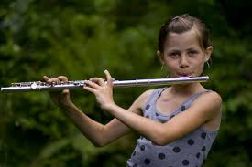
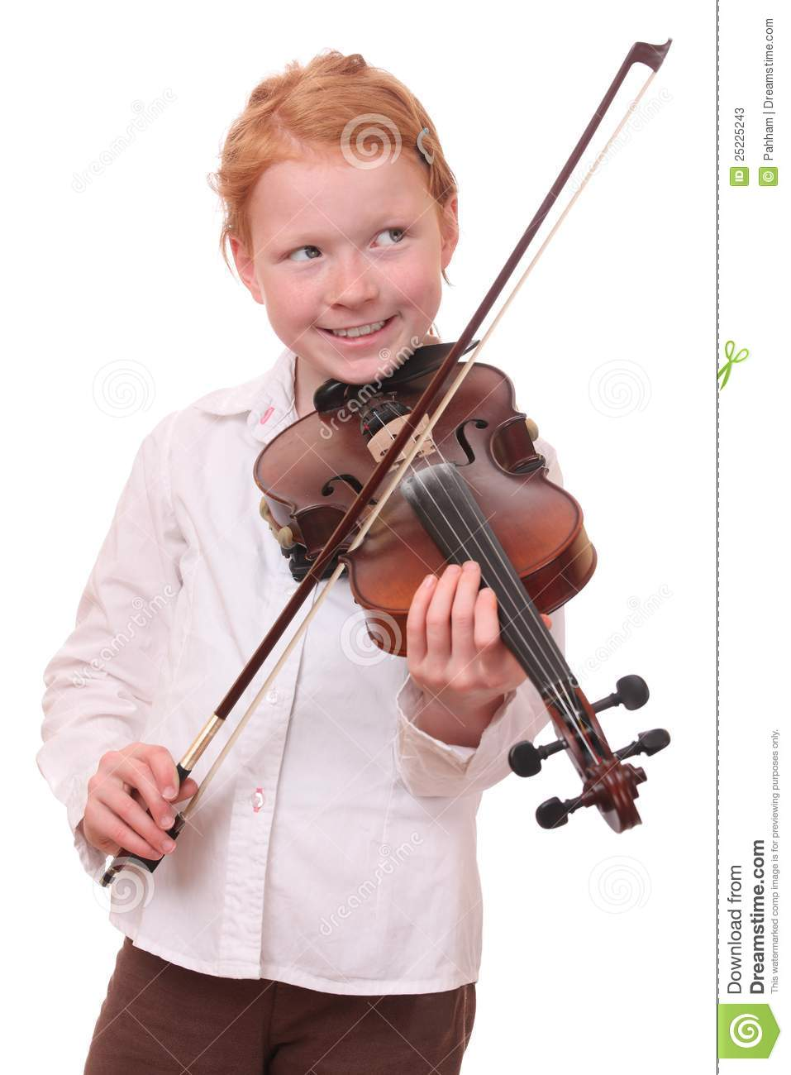
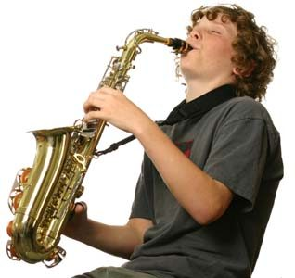
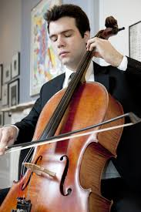
……………………………………………………………….
Permission for Music Lessons at KVC 2015

Student’s name ___________________________ Form Class ________

Instrument _______________________ (2nd choice if you have one) ________________________
I need to hire an instrument from the school Yes / No
Previous music tuition (new students only) _____________________________________________
Contact details for parent/caregiver Email _____________________________________________
Cell phone ______________________________ Home Phone _______________________
I have read the information above and
- I agree to pay the hire fee (this will be added to your fees invoice during the year)
- I agree to pay for repairs to an instrument damaged due to carelessness or neglect

Signed _________________________________________ (parent / caregiver)
(please print name ______________________________________ )

PRIVATE MUSIC TUITION AVAILABLE AT SCHOOL

The following lessons are available but are NOT funded by the Ministry of Education.
The tutors are from Activate Music Academy and registration and payments are made directly with and to them.

As with other lessons, they are
- 30 minutes, and in school time.
- Lesson times are rotated if possible to avoid missing the same class every week. Students are expected to do their best to catch up on class work missed.

TUTORS AND INSTRUMENTS
Voice (Amelia Mah)
Piano (Amelia Mah)
Guitar
Bass Guitar
Drum

* At the time of writing the tutors names were not confirmed.
* For some instruments there will be a minimum number of groups for the classes to proceed at school.
Cost:
Individual - $29 per 30 minute lesson
Paired - $17.40 per 30 minute lesson
Group - $8.70 per 30 minute lesson (3-5 students)

Further details can be found online http://activatemusic.co.nz/ including contacting for further information.

